
Ruskin Art Club,

A tax exempt 501 c (3) non-profit corporation,
www.RuskinArtClub.com

RUSKIN ART CLUB NEWSLETTER #3 SUMMER/FALL 2018
NEWS AND VIEWS SEPTEMBER 2018

FROM THE DESK OF EXECUTIVE DIRECTOR, GABRIEL MEYER:

Dear members and friends of the Ruskin Art Club:

Our fall season got underway on September 5 with the 19th Annual Ruskin Lecture at Doheny Memorial Library (USC) delivered by distinguished California historian, Prof. William Deverell. The director of the USC-Huntington Library Institute on the History of California and the West gave us a remarkable lecture entitled “Brash: Los Angeles in 1888” – this, in recognition of the 130th anniversary of the founding of the Ruskin Art Club. For all of you unable to join us for this insightful presentation, the Ruskin Lecture is already posted on Youtube (https://www.youtube.com/watch?v=R6B9Zsy-u_g) and will be shortly posted on our website: www.ruskinartclub.com.

Ruskin Art Club
(Founded 1888)

200 S. Ave. 66,
Los Angeles, CA 90042
info@ruskinartclub.com
(310) 640-0710

Executive Director
Gabriel Meyer

Board of Directors
President
Ron Austin

Vice-President
Kathleen Bonann Marshall

Treasurer
David Judson

Secretary
Eric Jessen

Members
Lyn Boyd-Judson
Noah Bretz
Elena K. Byrne
Tyson Gaskill
Suzanne Isken

September and October offer further opportunities to celebrate our anniversary. Please join us!

Time Sensitive!
RESERVE NOW FOR
A SPECIAL RUSKIN ART CLUB TOUR OF
THE HISTORIC GAMBLE HOUSE,,
FRIDAY SEPTEMBER 28, 2018;,5-7 p.m.

PLEASE SEND YOUR RSVP TO:
grmncr@aol.com or call (310) 640-0710.

Details page 2

COMING EVENTS TO ENJOY

FRIDAY SEPTEMBER 28, 2018; 5-7 p.m.
SPECIAL RUSKIN ART CLUB TOUR OF THE HISTORIC GAMBLE HOUSE, a Greene & Greene California Arts & Crafts masterpiece in Pasadena (USC School of Architecture). In addition to a docent-led tour of the house, Gamble House curator Jennifer Trotoux will give a special presentation on the new Gamble House exhibition, "Shiguchi: The Hidden Art of Japanese Joinery." A wine and cheese reception will follow on the terrace.
PLEASE SEND YOUR RSVP TO: grmncr@aol.com or call (310) 640-0710.
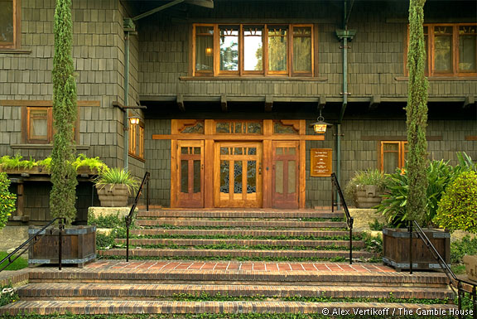
* For the tour, please wear flat shoes or shoes with two-inch heels or less (Gamble House policy).
The Gamble House
4 Westmoreland Place
Pasadena, CA 91103
5pm Lecture; 5:30 Tour; 6:30 Reception

SATURDAY, OCTOBER 13, 2018; 5-7pm
SPECIAL 130TH ANNIVERSARY RECEPTION: THE RUSKIN ART CLUB CLUBHOUSE
(800 S. Plymouth, Los Angeles, CA 90005) honoring the official anniversary of the founding of the RAC, October 13, 1888. Open to members of the Ruskin Art Club, family, and invited guests. Wine/hors d’oeuvres
PLEASE SEND YOUR RSVP TO: grmncr@aol.com or call (310) 640-0710.

SYMPOSIUM ON THE WORK OF POET, FARMER, AND ACTIVIST WENDELL BERRY
WEDNESDAY, OCTOBER 24, 2018; 10am-4pm

Doheny Library (USC), Room 240
Coffee/baked goods & lunch provided.
Presentations by David St. John, Christopher Merrill, and Sara Atwood
Poetry readings: Elena Karina Byrne and Gabriel Meyer, with a special screening of "Look and See: A Portrait of Wendell Berry” (produced by Robert Redford, Terrence Malick & Nick Offermann and directed by Laura Dunn, 2016)

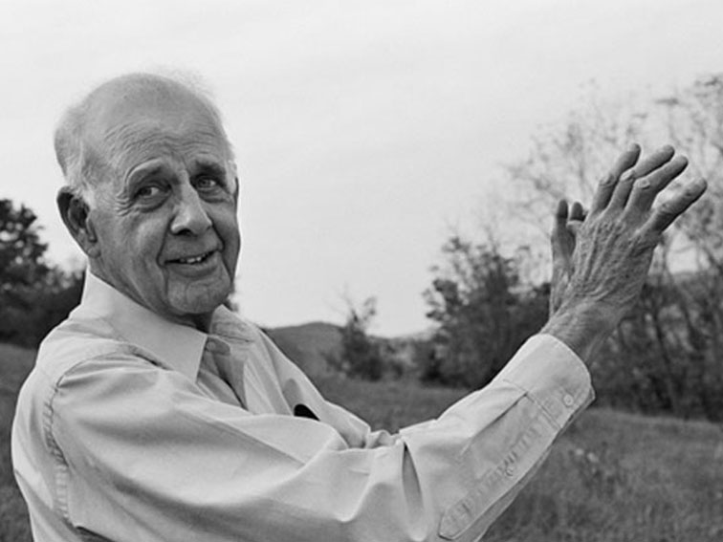
In 1965, poet Wendell Berry returned home to Henry County, Kentucky, where he bought a small farm house and began a life of farming, writing and teaching. This lifelong relationship with the land and community would come to form the core of his prolific writings. A half century later, Henry County, like many rural communities across America, has become a place of quiet ideological struggle. In the span of a generation, the agrarian virtues of simplicity, land stewardship, sustainable farming, local economies and rootedness to place have been replaced by a capital-intensive model of industrial agriculture characterized by machine labor, chemical fertilizers, soil erosion and debt - all of which have frayed the fabric of rural communities. In the course of this unfolding struggle, Berry, one of the great Ruskinians of our day, has become one of the most passionate and eloquent voices in defense of agrarian life.

Poet David St. John currently serves as Chair of the USC English Dept. and is one of the founding members of the PhD program in Creative Writing and Literature. Christopher Merrill, American poet, essayist, journalist and translator, currently serves as director of the International Writing Program at the University of Iowa. Dr. Sara Atwood is adjunct professor in English Literature at Portland State University and has written extensively on the thought of John Ruskin.

Schedule:
Morning session: Wendell Berry, the poet (David St. John, Christopher Merrill)
Afternoon session: Wendell Berry, the social and environmental activist (Sara Atwood); Discussion
A screening of “Look and See: A Portrait of Wendell Berry” will round out the day
PLEASE SEND YOUR RSVP TO: grmncr@aol.com or call (310) 640-0710.

SUNDAY, DECEMBER 2, 2018; 12:30 pm
ANNUAL CHRISTMAS PARTY AT THE DOHENY MANSION
Mount Saint Mary’s University
10 Chester Place; Los Angeles 90007
12:30pm (reservations required)
PLEASE SEND YOUR RSVP TO: grmncr@aol.com or call (310) 640-0710.

A RUSKINIAN TOUR (August 20, 2018)

As many of you know, this summer I visited Ruskin sites in the UK under the auspices of the Guild of St. George, a charity Ruskin founded in the 1870s to right some of the social wrongs of the day and to create lifestyle alternatives to the values of industrial society. More active than ever before, the Guild continues to promote the value of art, craftsmanship, and a sustainable rural economy, putting Ruskin’s ideas into practice in the 21st century. I wrote the following report on my nine-day tour for the Ruskin Art Club board of directors and thought you might enjoy reading it as well.
Gabriel Meyer
I had scheduled a research trip to Jerusalem this summer in order to finish work on a long-term book project. The Ruskin Art Club board of directors, taking advantage of the opportunity, urged me, with the encouragement of Guild Master Clive Wilmer, to add a tour of Ruskin sites in the UK to the itinerary.
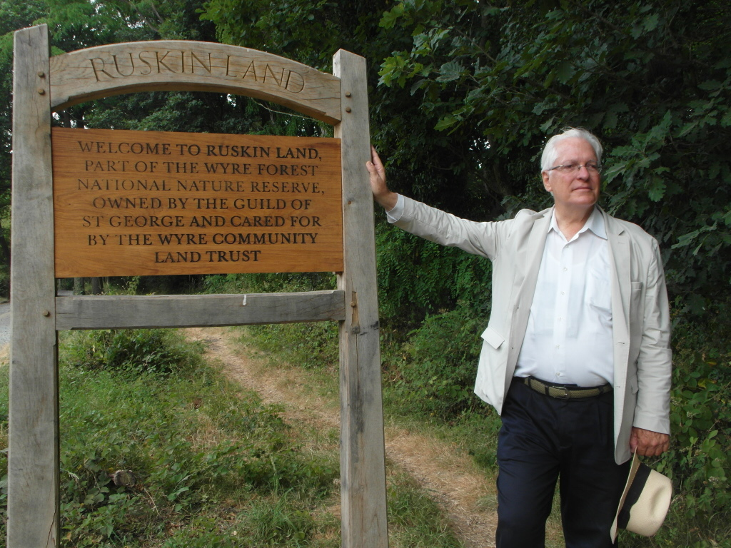
Along with Guild of St. George, the Ruskin Art Club of Los Angeles, celebrating its 130th anniversary, is one of the oldest Ruskinian organizations in the world and we’ve long wished to strengthen our ties with Ruskin scholars, organizations, and Ruskin-inspired efforts in the UK.
Beyond solidarity, however, the RAC leadership wished to learn from the Guild, the “original” Ruskin organization. In particular, from the Guild’s attempts to apply Ruskin principles to contemporary social and environmental concerns, to issues that have a serious bearing on modern life – what I like to call “applied Ruskin.” Since we too seek to enlarge the impact of our modest efforts by collaborating with other institutions, we thought that we could learn a great deal from the Guild about networking with other nonprofits and in fostering local, community-related outreaches. And, of course, we looked forward to introducing ourselves and what we’re doing in Los Angeles to new colleagues and friends in the broader Ruskin world.
Ruskin Land nature reserve (Wyre Forest)
On arriving in London, the first thing I did was to meet with the distinguished Ruskin scholar, Robert Hewison. We discussed the activities of various Ruskin groups in the UK and, in particular, his upcoming visit to the US next year, with the possibilities of a visit to Los Angeles. We also explored the idea of doing similar programs in Britain and Los Angeles on Ruskin’s birthday next year, centered on composer Sarah Rodgers’ chamber-music setting of Ruskin’s “King of the Golden River.”
Then on to Cambridge. There Clive Wilmer and I explored ways and venues through which Ruskin organizations and scholars might more effectively collaborate in the future. Scholar and craftsman Marcus Waithe, whom I met during his stay in Los Angeles several years ago, also enriched our discussions.
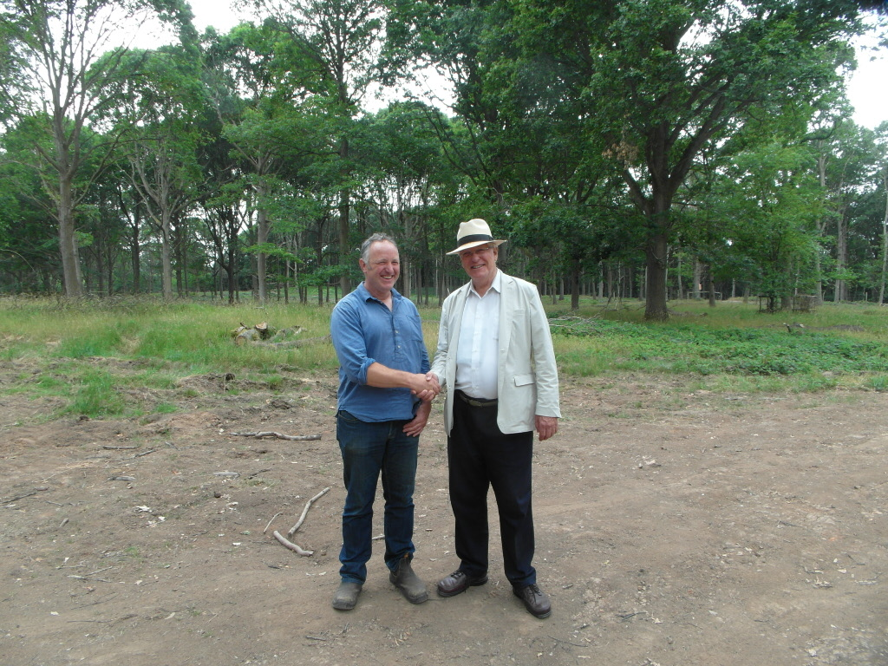
Bewdley was the next stop, where I was met by John Iles and given a tour of the idyllic river town and the even more idyllic Wyre Forest and Uncllys Farm. While rail schedules this summer made getting there something of a challenge, I was determined to visit Ruskin Land, in part because it was to visit such sites related to the “practical” work of the Guild that I had come. Due to Ruskin’s bequest, the Guild owns 100 acres of the historic forest and, therefore, a major responsibility for its upkeep and development. John and Linda graciously invited me to stay in the farmhouse, superintended by Archie, a no-nonsense but affable farm cat. John later escorted me on an insightful tour of the Guild’s work in Ruskin Land, during which I met Tim Selman and Jeanette Lock and others associated both with the Wyre Community Land Trust and with specific projects there. If I had expected to find a larger-scaled more “institutional,” problem-solving approach to environmental challenges, I quickly came to appreciate the way in which concerns about the environment in Ruskin Land had been deeply integrated into the special needs and character of the forest, of the place itself, and into the life and needs of the local Bewdley community. This struck me as profoundly Ruskinian – this emphasis, not on abstractions or abstract solutions, but on the needs and opportunities of a specific place and the challenges of living in community with it.
Tim Selman and Gabriel Meyer -- Wyre Forest

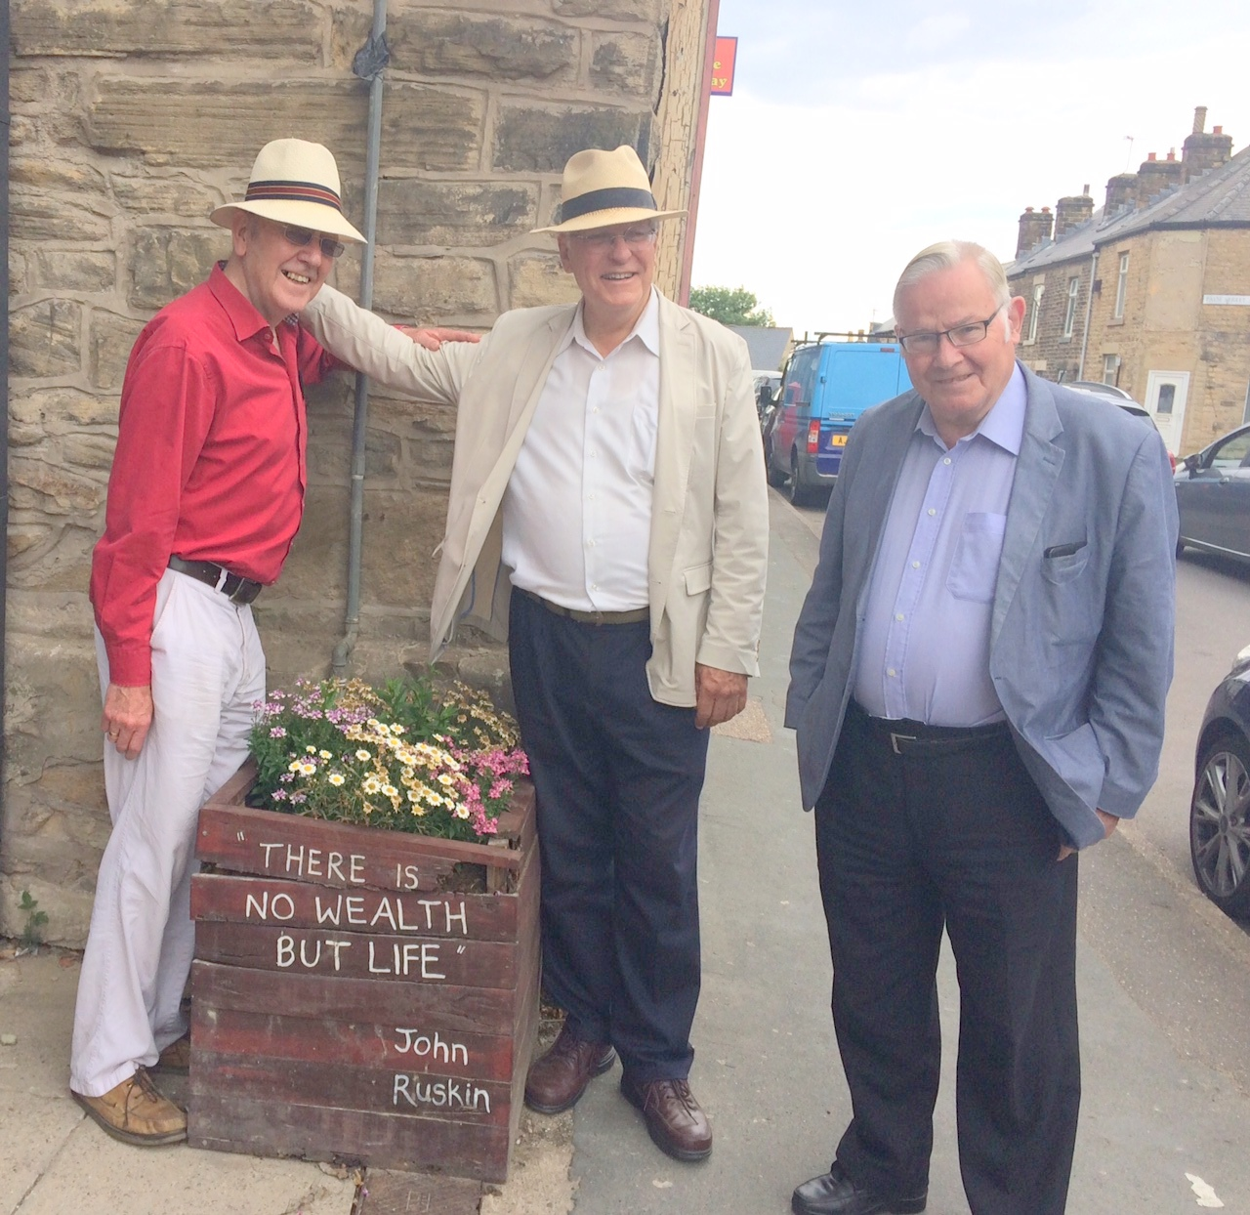
Sheffield was next on the list. Clive once again joined me there in this famous working-class city and site of the Ruskin Collection, heir to the famous St. George’s Museum Ruskin himself established at nearby Walkley in 1875 in order to educate and inspire the city’s metal workers. In Louise Pullen’s absence, Clive and Liz Waring took me around the current exhibits of Ruskin’s minerals, drawings, paintings, architectural casts and books in the Ruskin Gallery. In the gallery’s vault, Clive and I were able to peruse at leisure some of the collection’s other treasures, among them many of Ruskin’s most famous drawings – his bequest to the people of Sheffield. The indefatigable Ruth Nutter met us in Walkley, above Sheffield, to see the site of the original museum and to honor the memory of the two working-class curators of the original collection, Henry and Emily Swan. The Guild has recently restored Henry Swan’s grave and headstone in the Walkley cemetery. We shared a delightful lunch in town at Gerry’s bakery, which features loaves of “Ruskin” sourdough, with Guild Companions Gerry Gareth, Suzie Doncaster, Mike Pye and Carrie Leyland, local people, who, along with a master woodsman, Henk Littlewood, told me of the variety of their “ways” to Ruskin. The next day, on my way north, Ruth accompanied me on a visit to Meersbrook Hall, where I met Rhian Thomas, and saw the community arts-related activities that flourish there at a previous site of the Ruskin Museum. Due to the summer hiatus, I was not able to discuss Guild collaborations with the Ruskin Mill Trust staff in Sheffield, an innovative educational network based on Ruskinian principles, dedicated to helping special needs children and adults. As in Bewdley, it was significant to note how Ruskin’s ideas and the enterprises he inspired in Sheffield not only have managed to survive but continue to generate important new initiatives today.
Guild Master Clive Wilmer, Gabriel Meyer, and Mike Pye in Walkley
Before setting off on this journey, I (piously) indicated to people that I was in the UK to visit the “working Guild,” and that a tour of Ruskin’s idyllic estate at Brantwood, should it come about, would be an added bonus. One only says things like this if one has never been there. Happily, Clive and Howard Hull conspired to arrange what turned out to be an almost three-day “pilgrimage” to Ruskin’s lakeside paradise.
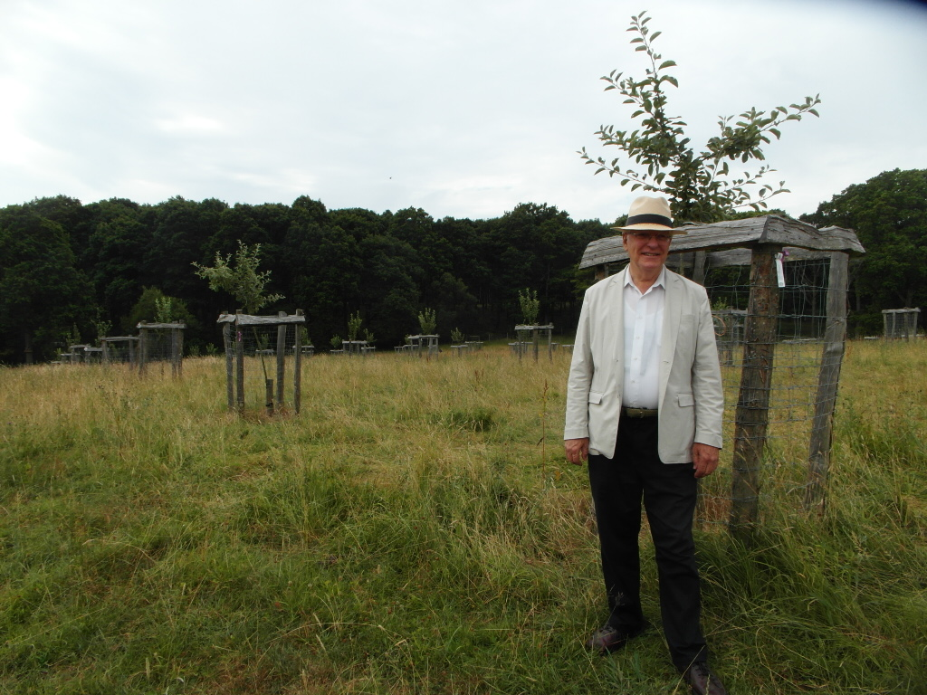
Ruskin's cherry orchard (Bewdley)
While in Brantwood, I had time for several leisurely discussions and meals with Howard and Pamela about the property and collection itself and its engagement with the local community. Howard and I were also able to spend some time in nearby Coniston, particularly in the town’s award-winning Ruskin Museum, established by Ruskin’s secretary, W.G. Collingwood in 1901, which boasts a fine, delightfully eclectic collection of Ruskin drawings, sketch books, lecture aids, and memorabilia.
The time also afforded me an informative meeting with Sandra Kemp from Lancaster University’s Ruskin Library. Time and the university schedule prevented me from visiting this largest and most significant of Ruskin collections, so I appreciated being able to meet Sandra and discuss some of the “institutional” challenges the collection is facing. While my visit to Brantwood brought me, as it must most visitors, a more vivid sense of the specifics of Ruskin’s life and world – the turret from which Ruskin viewed Coniston’s Old Man, the volcanic hill that dominates the terrain; the manuscripts of Ruskin’s musical compositions on the parlor piano – it is something else that I took away from Brantwood, and, indeed, from all the Guild sites that I visited. Instead of shrines to a great man and his legacy, which they could have remained, they are, in fact, all living centers of activity, places of vital engagement with people and communities today – the crafts festivals, community involvement in forest management and summer arts projects at Wyre, contemporary art exhibitions and Thursday summer barbecues for locals at Brantwood – ensuring that the memory of Ruskin, who preached that “there is no wealth but life with all its powers,” is well and truly served.
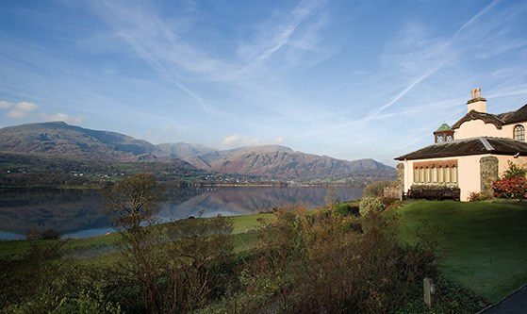

.
For news of Ruskin Art Club events
see: www.ruskinartclub.com
&
https://www.facebook.com/RuskinArtClub
Coniston Water from Ruskin's Brantwood estate.

